[05年新东方考前必背12篇作文（圣诞生日版）前言：今年2004年12月24日是我生日，所以想为大家做点什么，就把这个我原创的东西再来整理一下（1.加了Directions；2.重点句词加重加字符底纹；3.加了两篇应用文）。希望对大家有所帮助！同时也祝愿所有的考研朋友们——心想事成！]
————————————————————————————————————————————
新东方10大功能段落—
第一段：[1.现象/现状说明段] [2.图画/图表描述段]

第二段：[3.对立观点陈诉段]（四，六级多用） [4.利弊说明段]
[5.意义阐述段] [6.原因列军段] [7.举例段]

第三段：[8.归纳结论段] [9.趋势预测段] [10建议措施段]
————————————————————————————————————————————
第一部分 图画作文 （四篇）
- 关于爱心 （01年真题）

Directions:
Among all the worthy feelings of mankind, love is probably the noblest, but everyone has his/her own understanding of it.
There has been a discussion recently on the issue in a newspaper. Write an essay to the newspaper to
1) show your understanding of the symbolic meaning of the picture below,
2) give a specific example, and
3) give your suggestion as to the best way to show love.
You should write about 200 words on ANSWER SHEET 2. (20 points)

[1.现象/现状说明段] Love is of utmost importance to us humans. Everybody not only needs love, but also should give others love. As can be seen from the picture, "love is a lamp which is brighter in darker places. " This is indeed true. People in darker places need more light than other people. Maybe even a dim light can give them much hope for a better life. Maybe just a thread of light will call forth their strength and courage to help them step out of their difficulties.

[7.举例段] I can think of no better illustration of this idea than the following example(s).For instance when someone is starving to death, just a little food and water from you may save his(her) life. Again, when a little girl in a poor rural area drops out of school because of poverty, just a small sum of money from you may support her to finish school and change her life. In these case/circumstances you have given love which is like a lamp in a dark place where light is most needed.

[8.归纳结论段] To sum up, we should offer our help to all the needed. We expect to get love from others and we also give love to others. So when you see someone in difficulty or in distress and in need of help, don't hesitate to give your love to him (her). I believe that the relationship between people will be harmonious and that our society will be a better place for us to live in.
2. 空气污染(隐形杀手)

Directions:
A. Study the following cartton carefully and write and essay in about 200 words.
B. Your essay must be written clearly on ANSWER SHEET II.
C. Your essay should meet the requirements below:
1. Decribe the cartoon and the message conveyed
2. Draw a conclusion and give your comment on the cartoon
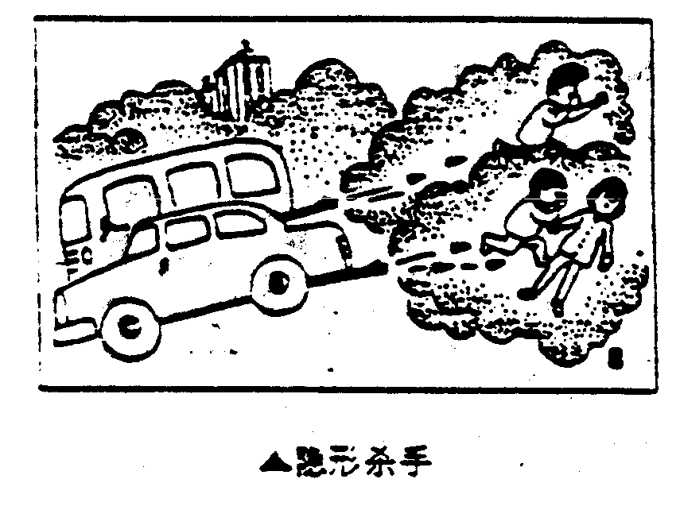

[2.图画/图表描述段] Pollution is becoming more and more serious all over the world. As is shown in the cartoon, two cars are giving off waste gas and three people are trying to avoid breathing in the poisonous gas by masking their face with their hands. The poisonous gas sent off by factories, domestic appliances and automobiles has made the air unhealthy for people to breathe.
[5.意义阐述段] There is no denying that automobiles are indications of civilization, progress and development; nevertheless , automobiles cause the serious problem of air pollution. Scientists have warned that unless effective measures are taken, the problem of pollution will eventually get out of hand. Actually, people are showing a real concern over the problem. For example, there is an increasingly loud voice from the public for firm action against pollution from automobiles.
[10建议措施段]Indeed, the earth is our home and we have the duty to take care of it for ourselves and for our descendants. In my opinion, we should work out concrete solutions to the problem of pollution from poisonous gas given off by automobiles. For example, the automobiles should be equipped with a device which can dispose of waste gas so as to prevent it from polluting air. Only in this way can we really solve the problem of air pollution caused by automobiles.
3. 沙漠化
Directions:
A. Study the following cartoon carefully and write an essay in about 200 words.
B. Your essay must be written clearly on ANSWER SHEET II.
C. Your essay should meet the requirements below:
1. Describe the cartoon and the message conveyed
2. Draw a conclusion and give your comment on the cartoon..
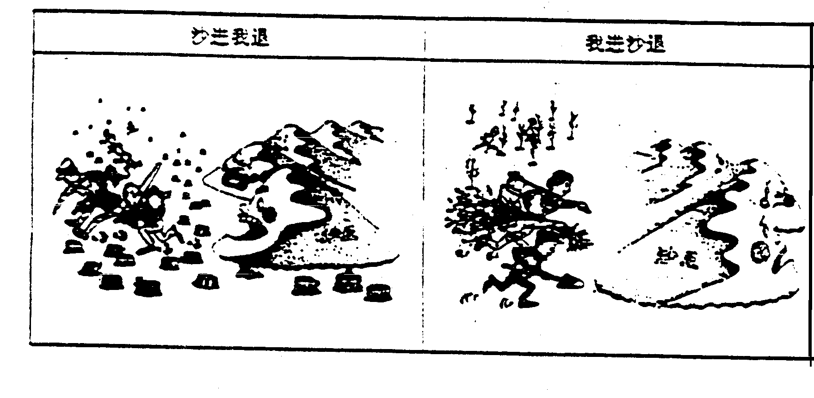
[2.图画/图表描述段]As is shown in the picture, we can see clearly the relation ship between people and desert. In the left hand picture, people are fleeing from greedy sand hills because they cut down all the trees. The caption reads, ”As the sand advances, we retreat.” In the right hand picture, the people have returned carrying tools, water, and young trees to plant the land again. The caption reads: “As we advance, the sand retreats. ”
[5.意义阐述段]It seems to me that the cartoonist is sending a message about the importance of trees in water and soil conservation and the need for everyone to fight against the danger of the desertification. In fact, what he is saying is that the sand hills will drive away from the land if we do fight against the sand. If we let this situation continue as it is , our environment will suffer a great destruction.
[10.建议措施段]The best way to fight back against the greedy desert in made clear in the second picture. There the local people are actively setting about the task of planting trees to reclaim the land and make it fertile. The fact that there are three people in the picture, each with a different job suggests that working together is the key to success in the battle against soil erosion.

4. 商业捕鱼（00年真题）

Directions:

- Study the following two pictures carefully and write and essay of at least 150 words.
- Your essay must be written neatly on ANSWER SHEET 2.
- Your essay should meet the requirements below:
1. Describe the pictures.
2. Deduce the purpose of the drawer of the pictures.
3. Suggest counter-measures.

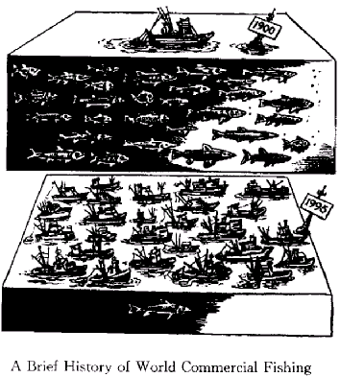

A Brief History of World Commercial Fishing
[2.图表描述段] As is shown in the pictures ,with the increase of commercial fishing ,the number of fishes dramatically(sharply) decreased .In one pictures ,there were various kinds of fish and only one fishing-boat in 1900 .On the contrary ,in1995 there was only one fish ,with many fishing-boats.
[5.意义阐述段] The purpose of this picture is to show us that due (great enough) attention has to be paid to the decrease (decline) of ocean resources .Owing to over-fishing the number of fishes has obviously dropped .If we let this situation go (continue) as it is ,we do not know where fish will be in the future .By that time ,our environment will suffer a great destruction .
[10.建议措施段] Therefore ,it is imperative for us to take drastic (effective) measures .For one thing ,we should appeal to our authorities to make strict laws to control commercial fishing .For another ,we should enhance(imperative arouse) the awareness of people that the ocean resources are very vital to us .Only in this way can we protect our ocean resources .Also I believe that we humans can overcome this difficulty ,and we will have a brighter future .
第二部分 图表作文（三篇）

5. 人口增长对野生动物的影响（99年真题）

Directions:
A. Study the following graphs carefully and write an essay in at least 150 words.
B. Your essay must be written neatly on ANSWER SHEET Ⅱ.
C. Your essay should cover these three points:
l. effect of the country's growing human population on its wildlife
2. possible reason for the effect
3. your suggestion for wildlife protection
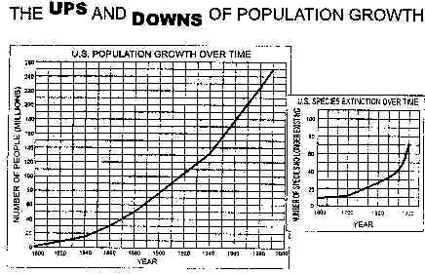

[2.图画/图表描述段] From these graphs, we can draw a conclusion that, with the growth of human population, the number of species has decreased rapidly in America, and some species have even vanished from our planet.
[6.原因列军段]Why does this phenomenon appear? There are several possible reasons for this. Above all, as the human population grows rapidly, a growing number of people came to live where some wild species have been living. Then these species have to move to other places. Some of them probably can not adapt to the new environment and die. In addition, although many people look on the wildlife as their friends, some people may not think so. They catch a lot of wild animals and sell them in order to get more money. Even worse(坏)/More importantly(好), as the result（中性） /consequence（贬义）of the industry, the natural balance and the ecologic environment are destroyed. The clear cutting has become increasingly serious. So some of the wildlife become homeless and extinct.
[10.建议措施段]In order to protect the wildlife, I have some suggestions. First, the governments should make laws to prevent them from being caught and killed. Second, the governments should educate people to love nature and protect it. Third, as for ourselves, we should take practical actions to protect our living environment.
6 烟草生产和消费（01年大纲样题）

Directions:
Widespread tobacco consumption has led to grave consequences, yet the tobacco companies still claim that they make a valbuable contribution to the world economy.
There is a discussion in a newspaper on the above two viewpoints.
Write an essay to the newspaper
1) criticizing their view and
2) justify your stand.
In your essay, make full use of the information provided in the pidctures printed below.
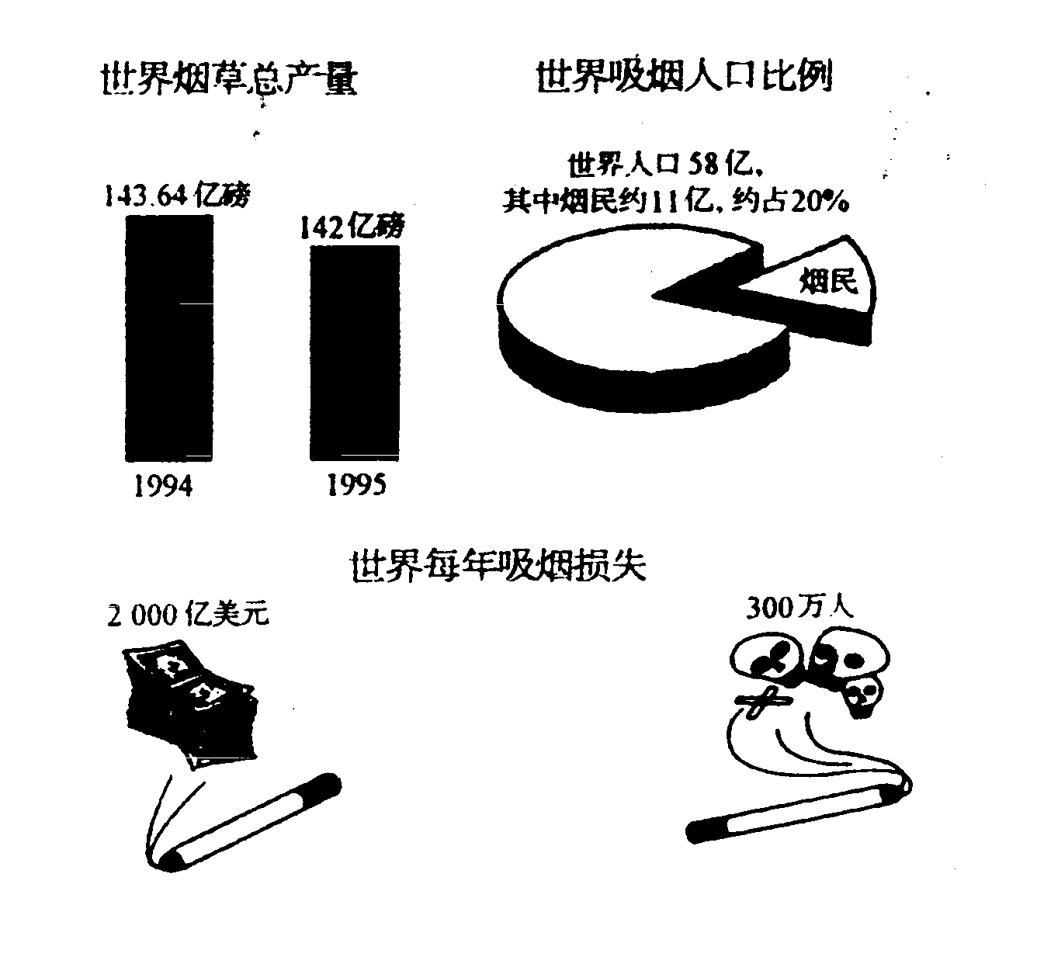

[1.现象/现状说明段]The majority of people would agree that cigarette smoking has caused serious problems. But the tobacco companies insist that they contribute greatly to the world economy by paying taxes to the government and employing hundreds of workers.

[4.利弊说明段]Personally, I believe that cigarette production and consumption threatens to do more harm than good. Firstly, smoking is responsible for many fatal diseases such as lung cancer, heart diseases and so on. According to the survey, tobacco consumers account for about 20% of the world population, and among them, three million people die from smoking-related diseases every year. The fact that the output of tobacco production is reduced from 143.64 billion pounds in 1994 to 142 billion pounds in 1995 also suggests that people have come to realize the negative effects of smoking. Secondly, tobacco consumption is extremely wasteful of money. As is indicated in the pictures, 200 billion US dollars is lost due to smoking each year. Obviously, the total loss of money around the globe substantially exceeds the gain in the industry.

[8.归纳结论段]In conclusion, as the economic development aims at making our life better, we cannot sacrifice our health for short-term financial benefits. If we have to spend more and more money providing medical services for those who suffer from smoking-related illnesses, the notion of promoting economy via tobacco production is not justifiable. It is high time that we fought for the total tobacco ban.
7. 日用花销统计
Statistics in People's Daily Expenses in Xi'an
Year  Item | 1995 | 1996 | 1997 | 1998 | 1999
Food | 66% | 61% | 48% | 41% | 36%
Clothing | 9% | 10% | 12% | 15% | 18%
Recreation | 4% | 5% | 8% | 9% | 11%
Others | 21% | 24% | 32% | 35% | 35%
Total | 100% | 100% | 100% | 100% | 100%

[2.图画/图表描述段]What is shown in the table above indicates that dramatic changes have taken place in the daily expenses in Xi' an from 1995 to 1999. The expenses on food have declined by 30% while those on clothing and recreation have increased respectively by 9% and 7%. The statistics of rise and fall seem to exist in isolation but closely related to one another.
[6.原因列军段]There are two factors accounting for these changes. Development in economy is an essential one in the five years. The increased income resulting from economic growth plays an important part in the less expense on food. Hence, a small percentage of total income is enough to cover food expense. Another one is the changes in life style. When food presents no worry to the average, people begin to focus more of interest on handsome appearance and happy leisure time. As a result of such a shift, spending on clothing and recreation increased year after year.
[9.趋势预测段]From the analyses made above, we may come to the conclusion that people's living standards in Xi' an have been constantly improved between 1995 and 1999. With the further growth in economy and more changes in life style, the tendency indicated in the table will continue in the table will continue in the better direction.

第三部分 应用文 （五篇）

为了简单而又正确，建议应用文书信一律采用“齐头式”，空行分段。

8.咨询信（1）
Directions:
You are preparing for an English test and are in need of some reference books. Write a letter to the sales department of a bookstore to ask for:（①情景描述）
1) detailed information about the books you want,
2) methods of payment,
3) time and way of delivery.（②提纲：）
You should write about 100 words on Answer Sheet 2. Do not sign your own name at the end of the letter. Use "Li Ming" instead. You do not need to write the address. (10 points)（③要求）

Dear Sir,

I'm now preparing for the National Entrance Test of English for Master's programs and I'm in urgent need of some reference books of English listed below:

1. A vocabulary book, preferably written by Zhou Gu
2. A collection of simulated English tests, by Bi Jinxian
3. An English grammar book, by Zhang Daozheng
4. A book on English writing.

I would appreciate it very much if you can, at your earliest convenience, let me know whether you have these books and, if yes, when and how I may get the books mentioned. And please tell me your preferred way of payment and I'll send you the money immediately.
（我将非常感激，如果在你最为方便的情况下，最好能让我尽快获悉你那里是否有这些书？如果有，何时，通过哪种方式，我可以获得这些书，同时请您告诉我您的首选付款方式，然后我会立即寄款于您。）

Sincerely,
Li Ming
————————————————————————————
9.咨询信（2）
A letter of Inquiry
You wish to study at a certain foreign university. Write a letter inquiring about the situation there as regards accommodation, fees and qualifications.

Dear Sir/madam

I am a Chinese citizen who wishes to study at your university. My plan is to start my course next term, and I would be grateful if you would be kind enough to provide me with certain essential information.

First, what qualifications do I need to follow a course of study at your university? I already have a master’s degree from a university here in China, but I wonder if there are any further academic requirements. Second, how much are the tuition fees? Although I intend to be self – supporting, I would be interested to hear if there are any scholarships available for international students. Third, what is the situation as regards accommodation? I would prefer a single room, which is more conducive to studying, but if single rooms are expensive, I would be willing to share.

I look forward to your reply, and to attending your esteemed institution.

Yours sincerely,
Li Ming
————————————————————————————
10．申请信
Directions: You are eager to apply for the position of a foreign enterprise advertised in a newspaper. Write an application letter that shows your major, specialty, ability in foreign languages and hobbies and expresses your strong desire to apply.
（你在报纸上看到一家外企的招聘广告，非常想去应聘。写一封申请信，内容包括专业、特长、外语能力、爱好等，并表明强烈应聘愿望）

Dear Sir,

Your advertisement offers a most tempting（有吸引力的、有诱惑力的）job to a young man just out of college. I can't think of any job I'd like better than a software development for a famous company like yours. I look upon it as a wonderful opportunity, and here is what I can offer you in return:

I am 22 years old, a hard working student who specialized in Computer Science and Application at Tsinghua University, from which I will graduate and get my BS degree in June this year. I can speak English quite well, and I am capable of programming in several computer languages and use computers very skillfully.

Besides, I like very much to participate in the group activities of all kinds. My work then becomes interesting and productive. The reason, in my opinion, is that working with people gives us power and competition. Rivalry is a very effective motive in improving one person's idea. So, group members may contribute different and essential resources to solve problems. Perhaps you will agree that these qualities─plus enthusiasm, persistence, and the willingness to work hard and long─make me acceptable for the job you offer as a beginner in your company. I believe I would do more and better work for you.

I enclose a letter of recommendation from Professor Liu, and a self-addressed（写明发信人姓名地址的）card, in hope that you will use it to tell me when to come for an interview.

And I look forward to hearing from you soon. (And your immediate reply will be greatly appreciated)

Sincerely yours,
Li Ming
————————————————————————————
11．建议信
A Letter of Advice/Suggestion
You have a friend who is about to enter university, and he wants you to advise him on which subject to specialize in – history, in which he is very interested, or computer science, which offers better job prospects.

Dear John,

You have asked me for my advice concerning whether you should study history or computer science at university, and I will try to make some useful suggestions.

You must keep in mind that, above all, your university training is a preparation for your future career. Therefore, your first consideration should be to study a subject which will best equip you to earn a living. There is no doubt that the field of computers offers far job opportunities than history.

Besides, we are now in the age of the high - technology revolution. For the foreseeable future, not only will it be necessary for everyone to be computer - literate, it will also be necessary for them to be equipped with computer skills merely to earn a living! History, I'm afraid, however fascinating it may be, offers few career prospects.

Of course, you don't have to devote all your time at university to studying computers and nothing else. On the contrary, I would recommend that you keep up your reading of history in your spare time. That way, you will find that your leisure hours are enriched while you prepare yourself for a worthwhile career in computers.

Yours sincerely,
James
————————————————————————————
12．推荐信
①要求：实事求是；
②内容：1. 推荐者与被推荐者的关系
2．推荐者与被推荐者认识时间长度。
3．被推荐者的能力与个性；
4．希望对方录用或者聘用被推荐者。

Dear Mr. Tan,

It is with a great pleasure that I recommend to you Miss Lu Yuan, an outstanding graduate（优秀大学毕业生）majoring in Business Administration（工商管理）of this university, for working in your company.

I have been in charge of Miss Lu's class since they were freshmen, so I know her well. She is hardworking, sincere, and ambitious. She is always avid for knowledge. She reads widely and actively participates in all kinds of activities. She took several courses in computer science which strengthened her administration ability.

In association with me, Miss Lu impressed me that she was a courteous, pleasant, and well-motivated lady. Her excellent communication ability and her good command of English add a lot to her managerial skills.

I think Miss Lu's education and character undoubtedly qualify her to serve as an administrator in your company. I recommend her without reservation and believe you will find her a helpful and responsible staff member.

Sincerely,
Za Jili, Chairman

（End）
————————————————————————————————————————————

